Jack

Detailed drawings of parts

All parts needing to be manufactured must be modeled in a solid-modeling program such as SolidWorks and appropriately dimensioned such that sponsors can fabricate more parts in the future. Isometric views and orthographic projections of each part should be produced. Assembly drawings should also be included. Standard engineering practices for labeling and dimensioning drawings should be followed, including a logical part and assembly numbering system. For ECE only groups, this requirement can be relaxed or we can ask for assistance from the MAE Department.

As appropriate, circuitry should be modeled using an appropriate modeling tool. Schematics shall be included with appropriate documentation so that sponsors can modify the part in the future.

---------------------------------------------------------------------------------------------------------------------

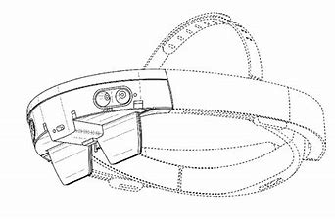

mspoweruser.com